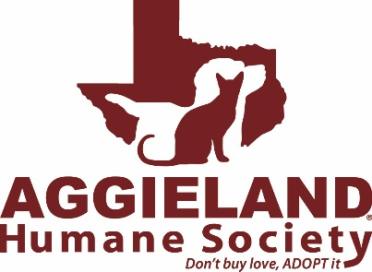

(Formerly Brazos Animal Shelter)

Board of Directors and Committee Application

Thank you for your interest in serving Aggieland Humane Society. Please submit the completed application to Kris Fraley at kfraley@brazoscountytx.gov. You may be contacted for an interview with the Board Governance Committee.
Board requirements/expectations from the Aggieland Humane Society (AgHS) by-laws:
- Serve a two-year term (with a maximum of 3 consecutive terms)
- Reside or own property in Brazos County
- Attend regular board meetings the 3rd Tuesday of the month
- Attend special board meetings as called
- Review and oversee the operations of Aggieland Humane Society
- Annually approve the budget
- Support AgHS with both personal contributions and solicitation of contributions from others
- Serve on one or more of Board’s working Committees
- Attend an Inspiring Tales tour as part of the onboarding process

Aggieland Humane Society Committee requirements/expectations:
- Attend committee meetings
- Analyze, plan, and implement projects to further committee initiatives
- Report committee needs, work, and progress to the Board of Directors
__________________________________________________________________

Name:

Position(s) interested in? (Check all that apply)
☐ Shelter Medicine Committee
☐ Governance Committee
☐ Development Committee
☐ Wiener Fest Subcommittee
☐ Inspiring Tails Subcommittee
☐ Spay/Neuter Ad Hoc Committee
☐ Facilities Ad Hoc Committee
☐ Board of Directors (Please note that in addition to the application Board applicants must also submit a résumé/curriculum vitae and contact information for three references)

Address:

Home Phone:

Cell Phone:

Work Phone:

Email Address:

Why do you want to be involved with Aggieland Humane Society?

Have you been on any other boards or committees in the community? If so, please describe and include the timeframes.

Have you been a member or volunteer of an animal welfare or animal rights group? If so, please describe and include timeframes.

What Board activities would interest you (fundraising, public relations, event planning, policy, etc.) and what skills do you bring to those efforts?

Once again, thank you for your interest in serving Aggieland Humane Society Board. A member of the Governance Committee will be in touch with you shortly.

